|  |  |
| --- | --- |
| **Evidences Required** | **Results** |
| Method of extraction | Execute Query |
| User extraction process performed by | DAS,ASISH |
| Users list count per screenshot should match with the actual users list submitted | 08 |
| Date when the users list was extracted | 08/28/2017 |

# HPA User List Extraction

Below is the SQL query used by Asish Das (502035342) to extract highly privileged accounts for the application EBS2. The query extracts all highly privileged accounts from the Oracle SQL developer, includes all types of users who have access to the application. The query result produces a complete and accurate listing of all highly privileged users to the best of our ability. As on 8/24/2017, the query fetched 8 users having access to this application and I confirm that the users list is complete and accurate.

**Below is the query used to extract the highly privileged accounts.**

select distinct SCUSER ID, ABALPH, ULUGRP, TO_CHAR(TO_DATE(SCSECLST+1900000,'YYYYDDD'),'MM-DD-YYYY') Security_Last_Updated_Date

from sys7334.F0092 a, sys7334.f98owsec b, proddta.F0101 c

where a.ULUSER = b.SCUSER

and a.ULUSER = c.ABALKY

and (a.ULUGRP = 'CNCADMIN' or a.ULUGRP = 'EBSADMIN' or a.ULUGRP = 'EBSDBSADMN')

and b.SCEUSER = '01'

and (c.ABAT1 = 'E' or c.ABAT1 = 'FN')

order by ULUGRP

The query extracts 8 Highly privileged accounts from the application.

**Query Results:**

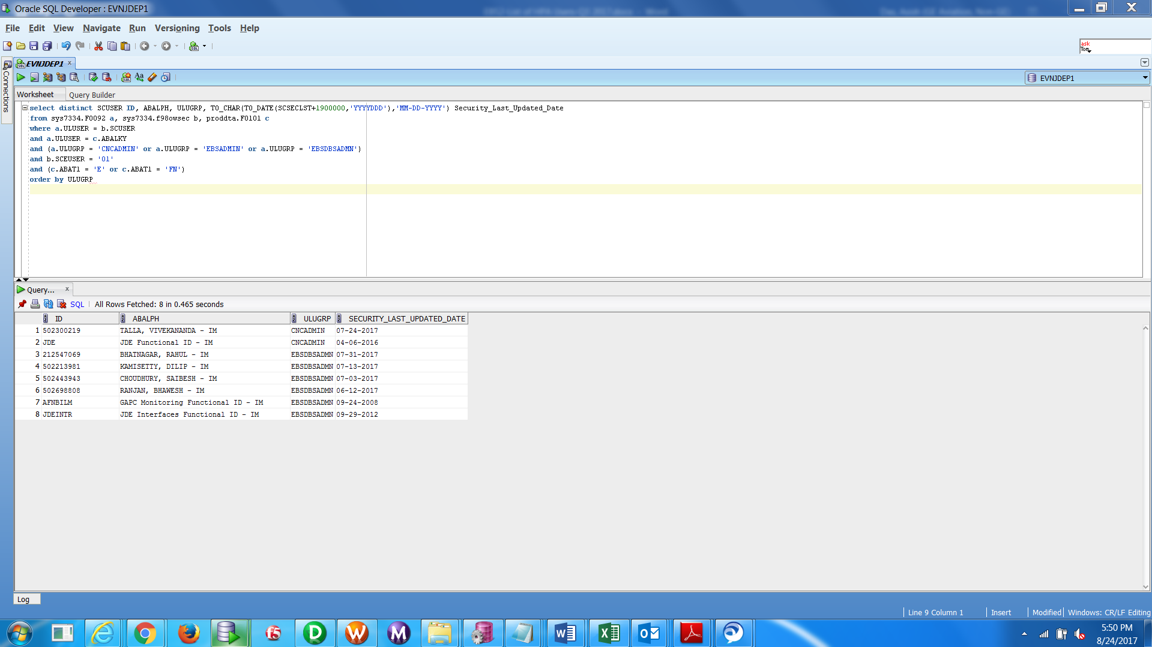

Provides the total no. of users extracted.

Below snap shot shows the date and time of HPA extraction

Attached is the HPA user list in excel format with authorized owner information.



Attached is the mail evidence regarding that.

